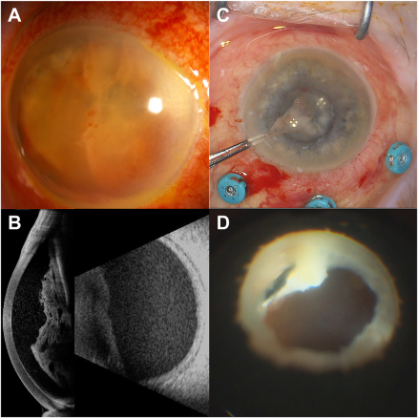

One week after a 6-day bout of watery febrile diarrhea, an 85-year-old pseudophakic White woman, followed up for a relapsed multiple myeloma, presented with sudden unilateral vision loss (20/20000). Severe panuveitis with a massive fibrino-hemorrhagic cyclitic membrane (A) extending to the capsular bag (B) was documented. The results of blood cultures, brain magnetic resonance imaging, whole-body computed tomography scan, and transthoracic echocardiogram were negative. Massive inflammation was removed by cleaning fibrin in the sulcus (C) and sticky retrolental abscess (D). Complete healing occurred without subsequent complications: vision improved until 3 months and then remained constant (20/32, Jaeger 1). Based on the provided images and clinical description please make an ophthalmic diagnosis for this patient. And output the diagnostic conclusions only.

Endogenous Endophthalmitis 内源性眼内炎